This is the title of your presentation: presenting urban development in Indonesia

(First name) (Last Name)¹* and (First name) (Last Name) ²

¹Department of Architecture, Faculty of Technology and Design, Universitas Pembangunan Jaya, Tangerang Selatan, Indonesia

²Centre for Urban Studies, Universitas Pembangunan Jaya, Tangerang Selatan, Indonesia

Abstract. This study investigates the correlation between urban development and crime rate in xxx. The study involves collaboration between engineers, economist, etc. This is where you write your abstract

Keywords: landscape architecture,urban development, real estate, property development, relationship, education

- INTRODUCTION

This section discusses background, importance, and contribution of the research paper to the field of study.

This is the second paragraph of the introduction [5].

- URBAN DEVELOPMENT AND URBAN CHALLENGES
The economic development of a country in particular, or the country in general, is the development that the real estate industry will account for in a single industry.

This is the second paragraph about land and real estate.

2.1. Subtopic 1

Discussion about subtopic 1..

2.1.1. Sub-subtopic 1

2.1.2. Sub-subtopic 1

2.2. Subtopic 2

Discussion about subtopic 2

2.3. Subtopic 3
- RESEARCH METHODOLOGY

- DATA ANALYSIS

- CONCLUSION AND FUTURE WORK

Note that figures and tables can arranaged in one colum or two columns, depending on their sizes.

Figure 1: example of figure, taken from JDBE 15 (2), 2015.

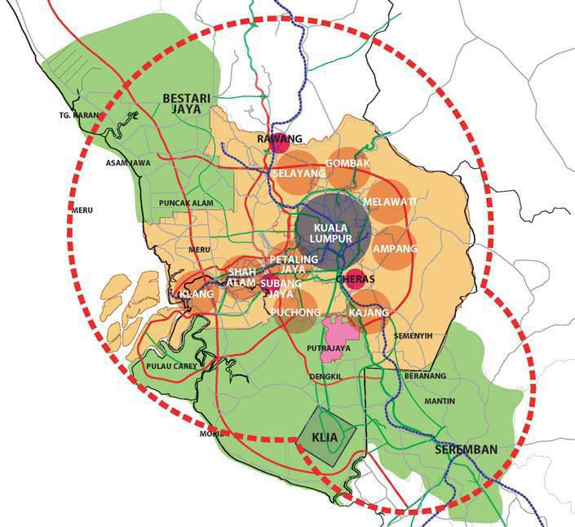

Table 3: Example of table, taken from JDBE 15 (2), 2015

Variable | Gender | Min | sp | t | sig
Function Urban Park | male | 2.92 | 0.22 | -.384 | .703
 | female | 2.94 | 0.14
Perception | male | 2.73 | 0.30 | -.858 | .396
 | female | 2.81 | 0.29
Satisfaction | male | 2.65 | 0.39 | 1.429 | .161
 | female | 2.46 | 0.50
Health | male | 2.97 | 0.09 | -.210 | .835
 | female | 2.97 | 0.11
Ecology | male | 2.73 | 0.28 | .564 | .575
 | female | 2.68 | 0.30
Planning | male | 2.87 | 0.23 | 2.037 | .047
 | female | 2.72 | 0.27

- ACKNOWLEDGEMENT
This section allows you to acknowledge funding agencies, collaboration, etc that may be fruitful during this work.

- REFERENCES
- Kuhad, R.C., R. Gupta & A. Singh. Microbial cellulases and their industrial applications. Enzyme Research 2011: doi:10.4061/2011/280696 (2011).
- Juturu, V. & J.C. Wu. Microbial cellulases: Engineering, production and applications. Renewable and Sustainable Energy Reviews 33:188–203 (2014).
- Davies, G. & B. Henrissat. Structures and mechanisms of glycosyl hydrolases. Structure 3: 853-859 (1995).
- Sukumaran, R.K., R.R. Singhania & A. Pandey. Microbial cellulases-production, application and challenges. Journal of Scientific & Industrial Research 64: 832-844 (2005).
- Sadhu, S. & T.K. Maiti. Cellulase production by bacteria: A review. British Microbiology Research Journal 3: 235-258 (2013).
- Sreena, C.P. & D. Sebastian. Cost effective cellulase production by Bacillus subtilis MUS1 using lignocellulosic biomass residues. Biodiversity and Evaluation: Perspectives and Paradigm Shifts 2015: 268-270 (2015).
- Subramaniyam, R. & R. Vimala. Solid state and submerged fermentation for the production of bioactive substances: a comparative study. International Journal of Science and Nature 3: 480-486 (2012).

